

ADAPTIVE LEARNING FOR NEURODIVERSITY

In Partial Fulfillment of the Requirements for the Degree in Bachelor of Science in Computer Science Major in Software Engineering

Proponents:
Salamatin, Jana Quisha
Onas, Maria Kaitlyn
Juaiting, Zia Caira

Adviser:
Prof. Jayson S. Viernes

March 2026

Table of Contents

Table of Contents 2
Chapter I: Introduction 4
Overview of the Current State of Technology 4
Project Objectives 5
General Objective 5
Specific Objectives 5
Scope and Limitations 6
Methodology 7
Planning 8
Requirement Analysis 8
Design and Development 9
Implementation 9
Testing 9
Deployment and User Feedback 9
Chapter II: Review of Related Literature 11
Related Literature 1: Title Goes Here 11
Related Literature 2: Title Goes Here 12
Related Literature 3: Title Goes Here 13
Summary 14
Chapter III: The Proposed System 15
The System 15
Entity-Relationship Diagram (ERD) 16
Data Flow Diagram (DFD) 17
Data Dictionary 19
Process Specification 20
Software Requirements Specification 22
Mockup Screen 23
References 25

Chapter I: Introduction

Overview of the Current State of Technology

In a study conducted by Farheen and Kouser (2025), an adaptive learning environment was introduced specifically for neurodiverse students. In this type of learning, Artificial Intelligence technology is combined with Universal Design for Learning (UDL) principles to enable the personalization of learning based on cognitive profiles, learning styles, and engagement levels. Some of the most important features of the learning environment include multimodal learning delivery and pacing adjustments.

Iliska and Gudoniene’s (2025) research demonstrated that sustainable technology-enabled education programs provide essential support for students who have dyslexia. This shows that personalized educational software is effective in improving and enhancing reading comprehension and engagement when it comes to learning. The research proves that inclusive design is a vital approach to ensure equal educational opportunities for students with reading disabilities.

A research study by Al-Azawei et al. (2016) examined the applicability of the Universal Design for Learning (UDL) strategy in addressing the learning gaps for students with different learning abilities and personal preferences regarding education. It was found that adaptive learning management systems, or LMS, compared to traditional LMS, are enhancing learning engagement and accessibility for learners with neurodevelopmental disorders. It was revealed that it was even more effective in an online learning setting. The aspects emphasized for inclusive learning are personalized UI and multisensory learning materials.

In another research study carried out by Baradari et al. in 2025, they targeted a neuroadaptive AI tutor named NeuroChat that combines electroencephalography (EEG) and generative AI, which monitors the progress of learners in real-time and adjusts the content delivery and difficulty levels by utilizing a closed-loop system. The findings revealed a positive outcome and concluded that the application of an adaptive learning tutor increases cognitive learning, engagement in learning, and understanding of the material.

On the basis of the research conducted by Samuel et al. (2022), the study is based on a bibliometric analysis of the use of technology, such as Artificial Intelligence and other technological aids, to help neurodiverse employees in the workplace. The analysis of the study examines how neurodiversity, such as Autism Spectrum Disorder (ASD), ADHD, Dyslexia, and Dyspraxia, is a natural variation in the brain that can be harnessed through technological means. The findings of the study show that the proper use of new technology can redefine the working environment by making it more efficient and providing real-time support for neurodiverse employees, which will create a more creative and socially conscious working environment.

Although the current studies have revealed the potential effectiveness of adaptive learning systems, assistive technology, and AI-powered learning assistants, there are still some gaps that should be filled. Most of the current solutions are either designed for a particular neurodevelopmental disorder or address a particular aspect. There are very few solutions that take a comprehensive approach and address multiple aspects simultaneously. Assistive technology with inclusive software engineering is a strategic way to support neurodivergent students. This is a crucial aspect to promote autonomy and academic success of the students (Sousa and Harb, 2025).

Project Objectives

General Objective

The general objective of this project is to develop an adaptive educational software that personalizes content delivery, pacing, and user-interface design to cater to students with neurodivergent needs.

Specific Objectives
- To design a user interface that accommodates learning disabilities through features such as dyslexia-friendly fonts, adjustable color contrasts, and simplified layouts.
- To integrate accessibility tools into the software, such as text-to-speech, adjusting text sizes, and visual customization to support cognitive and sensory needs. ‘
- To develop an adaptive learning mechanism that changes the lesson pacing and difficulty based on the students' real-time interaction through their performance and engagement.
- To evaluate the effectiveness of the software in its effectiveness to improve engagement, comprehension, and learning outcomes.

Scope and Limitations

The proposed system is intended to be designed and eventually developed to provide adaptive learning software that aids neurodivergent learners by adjusting the interface, learner pacing, and content dissemination to their needs to ensure comprehension and mastery. The adaptive content is intended for learners in the elementary to lower secondary levels, approximately, learners who are aged 5 to 15 years old. The app aims to address learning difficulties faced by students who have Attention-Deficit/Hyperactivity Disorder (ADHD), dyslexia, and sensory issues. It will also cover basic foundational learning skills, namely reading comprehension, basic mathematics, and memory retention. The app features include a sensory-friendly interface that can be personalized for each learner (brightness, color contrast, font spacing, etc.), different content delivery modes, customizable learning pacing, and a dashboard or homepage to track learner progress.

The proposed application has significant features to be highlighted; however, just like any other application, it has several limitations that cannot be addressed and accommodated as of the moment but can be addressed in a future patch release. In the initial deployment, the software can only be of help to learners with dyslexia, sensory, and ADHD related learning difficulties. It cannot provide therapy-like intervention for learners with severe autism disorders as of yet. The specialized software also cannot be used to diagnose developmental disorders and learning difficulties, as it is educational software, and diagnosis must still be left to the provision of professional medical doctors.

Methodology
The development of adaptive learning software will use the Incremental Model methodology for the software development process. This approach is highly suitable for the project as it offers flexibility, allowing modifications to be made to requirements, design, and implementation in response to evolving user demands and feedback. Additionally, the incremental model enables the deployment of functioning software components at an early stage, enabling user testing and validation prior to full deployment.

Development Tools
Android Studio | IDE
Github | Application Version Control
Firebase Realtime Database (NoSQL) | Database
Firebase Cloud Messaging | Push Notifications
Figma | Wireframe / Design

Programming Languages / Frameworks
React / Angular | UI Framework for customizable layouts and component-based architecture
Python (NLP libraries) | Text-to-speech, speech-to-text, and vocabulary simplification
TensorFlow / Scikit-learn | AI/ML models for adaptive content and engagement analysis

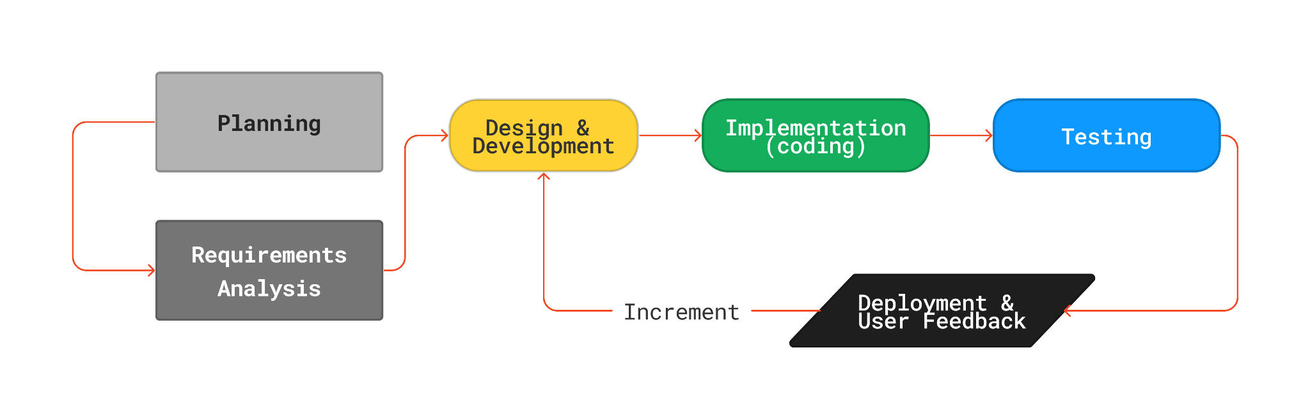
Fig. 1.0: Incremental Software Process

The proposed system, System Name, will be using incremental model methodology for the software development process. The project team believes that this approach is highly suitable for the project for several reasons. First off, the model offers flexibility in the development process, allowing modifications to be made to requirements, design, and implementation in response to ever-changing user demands and feedback. This is vital for a system like a digital lost and found, which could have evolving user requirements and needs to be able to adapt and react to changing circumstances. Additionally, the incremental model enables the deployment of functioning software components at an early stage of development, enabling user testing and validation which will be greatly beneficial, as identification of issues or defects through early feedback enables them to be fixed prior to deployment of the finished product.

The model's phases involve the following:

Planning
This phase involves identifying the overall scope and objectives of the system. The project team determines what features the system should have. During this phase, the team also decides how the development process will be managed, including the software development methodology, the tools and resources required, and the team's roles and responsibilities.

Requirement Analysis
This is a crucial phase as the project team analyzes the requirements of the system in more detail. This involves breaking down each feature into smaller components and identifying any technical requirements that must be met to implement each component. During this phase, the team also identifies any potential challenges or obstacles that may arise during the development process.

Design and Development
In this phase, the project team proceeds to design the system architecture, user interfaces, and any necessary technical designs. By using tools such as Figma for the wireframe and design, it will help the team provide a visual representation of the system. During this phase, the team also considers how each feature will be integrated and programmed into the system.

Implementation
In this phase, the team codes the system components that were designed in the previous phase and integrates them into the overall system. The team also performs unit testing to ensure that each component works as planned.

Testing
In this phase, the overall system undergoes well-performed testing to ensure that it meets the requirements and functions as planned. The team performs both functional testing, which tests the system's features, and non-functional testing, which tests the system's performance, security, and reliability. Any defects, issues, or bugs identified during testing are documented and resolved.

Deployment and User Feedback
In this phase, the system is deployed to the users. The team monitors the system to ensure that it is configured correctly and running smoothly. During this phase, the team also collects feedback from the users to identify any issues or areas for improvement. The team evaluates the feedback and determines whether changes or updates need to be made to the system. Based on the feedback and evaluation, the team updates the system and may add new features or make changes to existing features. The phases may be repeated several times until the system is fully developed and implemented.

Chapter II: Review of Related Literature

This chapter will introduce the theoretical background and existing systems that are related to the development of the proposed adaptive learning software for neurodiverse learners. This includes the established theories in education that support adaptive learning, as well as existing systems that show the application of assistive and adaptive technology in education. These theories and systems form the basis for the proposed system.

Related Theories
Cognitive Load, Flow, and the Social Constructivist Theories yield an extensive and solid educational foundation for an adaptive learning system for neurodiverse learners. In addition, existing systems demonstrate the growing role of assistive technologies in supporting the needs of neurodivergent learners. However, gaps remain in their inclusive designs. The following systems contain approaches that support neurodivergent learners through accessible interface design, gamification, and real-time intervention for personalized experience.

Cognitive Load Theory
The Cognitive Load Theory emphasizes the need for minimal instructional material, where the UI is simplified, pace is adjustable, and multimodal delivery is available to avoid cognitive overload (Sweller, 1988).

Flow Theory
It is established that when cognitive load is regulated, neurodiverse learners are better able to reach an optimal mental state, as mentioned in the Flow Theory by Mihaly Csikszentmihalyi, which transpires when there is a balance between the task’s difficulty and the learner’s skill. Neurodiverse learners are expected to respond positively to educational materials if frustration is prevented, anxiety is regulated, and boredom is contained (Steimer, 2021).

Social Constructivist Theory
Furthermore, the Social Constructivist Theory by Lev Vygotsky strengthens the significance of cognitively balanced learning by emphasizing the role of sociocultural interaction, such as the importance of the instructors and their support in the process of learning, by giving feedback and encouraging collaborative learning rather than just information absorption (Social Constructivism - GSI Teaching &amp; Resource Center, 2017).

The three theories not just assist, but also empower neurodiverse learners through a mental, welfare, and social-centered pedagogy. These theories work hand in hand to prove that when cognitive load is managed, attention and engagement are maintained through regulated task difficulties, and learning is collaborative and supported, it will create an adaptive and diverse educational space for learners.

Related System 1: Accessibility-Focused and Gamified Learning Systems
An accessibility-focused research by Alsudays (2021) emphasized the importance of user interface design tailored for learners with dyslexia. These design principles ensure that educational platforms are inclusive and comfortable for learners with sensory and reading challenges.

Gamifying and using serious game interventions to create a motivation-driven learning environment for neurodiverse learners. A systematic review by Lin J and Chang W found that serious games can improve attention, executive functioning, social skills, motor coordination, and overall engagement in children with ADHD. Recent studies by PT et al. (2025) suggest that adaptive gamification, multisensory content delivery, personalized feedback, and AI-driven analytics show strong potential in improving engagement and learning outcomes.

Related System 2: Real-Time Adaptive Learning Systems
Real-time adaptive systems show how dynamic data can personalize learning and provide behavioral support. DreamBox Learning adjusts lesson difficulty and pacing based on how a student is performing, while the attention-driven read-aloud system developed by Gabriele Schiavo uses eye-gaze tracking to modify narration speed and emphasis to reduce cognitive overload. Similarly, Mightier integrates heart-rate biofeedback into gameplay that makes students practice coping strategies that support and enhance their emotional and behavioral regulation in real time.

Ultimately, while these systems demonstrate that effective support for neurodivergent learners can be achieved through inclusive interface design, motivational game-based strategies, and real-time adaptive technologies, however, these systems address only specific aspects of support.

Summary
The Cognitive Load Theory, Flow Theory, and Social Constructivist Theory form a strong educational background for the proposed adaptive learning system. These theories highlight the importance of cognitive load management, balancing task difficulty with skill level, and guided support. Existing adaptive and assistive systems have already proven the success of accessibility design, gamification, and real-time interventions. But most of the existing systems are limited to particular aspects of support. The proposed project aims to combine all these aspects into a single adaptive educational system for neurodiverse students.

Chapter III: The Proposed System

The System
The proposed system, Adaptive Learning for Neurodiversity (ALN), is an educational software application designed to support neurodivergent learners aged 5 to 15 years old. The system personalizes the learning experience by adjusting the user interface, content difficulty, and pacing based on each learner's real-time performance and engagement levels. The core of the system is an AI-driven adaptive engine that continuously monitors interaction data and modifies the learning path accordingly.

The system is built around three primary user roles: the Learner, who engages directly with the adaptive content; the Parent/Guardian, who monitors progress and adjusts settings; and the Administrator, who manages content and system configurations. Each role has a dedicated interface tailored to their needs, ensuring a seamless and intuitive experience across all user types.

Key features of the system include a sensory-friendly interface with customizable brightness, font type, font size, and color contrast settings; multimodal content delivery through text, audio, and visual formats; text-to-speech and speech-to-text functionality powered by NLP; an adaptive lesson engine that adjusts pacing and difficulty in real time; and a progress dashboard for tracking learner milestones and engagement trends.

Entity-Relationship Diagram (ERD)

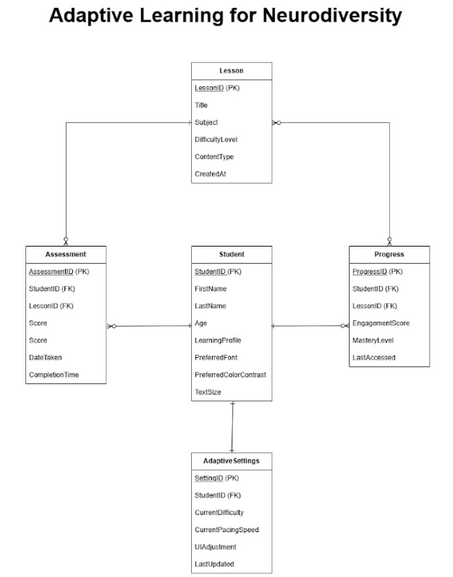
Fig 5.0: ERD Diagram

The Entity-Relationship Diagram (ERD) above illustrates the data structure of the ALN system. The primary entities are the Learner, Parent/Guardian, Administrator, LearningModule, LessonContent, and ProgressRecord. The Learner entity contains attributes such as LearnerID, LearnerName, Age, DiagnosisType, UIPreferences, and ParentID. The LearningModule entity contains ModuleID, ModuleTitle, DifficultyLevel, SubjectArea, and TargetAge. Each LessonContent is linked to a specific module and holds ContentID, ContentType (text, audio, or visual), ContentData, and DifficultyScore. The ProgressRecord entity logs LearnerID, ModuleID, SessionDate, EngagementScore, CompletionStatus, and AdaptedDifficulty, enabling the system to track individual learning trajectories over time.

Data Flow Diagram (DFD)

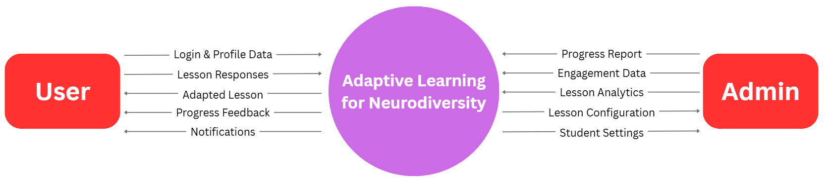
Fig 6.0: Level 0 DFD

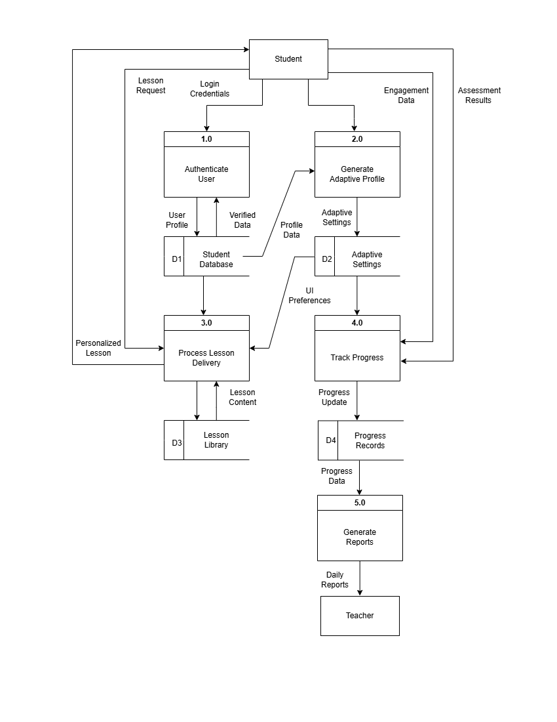
Fig 7.0: Level 1 DFD

The Data Flow Diagrams above show how data moves through the ALN system at two levels of abstraction. At Level 0 (Context Diagram), the main external entities such as Learner, Parent/Guardian, and Administrator interact with the central ALN system. The Learner submits interaction data and receives personalized content; the Parent/Guardian sends preference settings and receives progress reports; the Administrator manages module content and receives system usage analytics.
At Level 1, the system is broken down into its core processes: Account Creation and Verification, Login and Authentication, Learner Profile Setup, Content Delivery, Adaptive Engine Processing, Progress Tracking, and Notification Generation. The adaptive engine process is the most critical, as it receives real-time engagement and performance data from the content delivery process and feeds adjusted parameters back into the lesson sequencer, completing the closed-loop adaptive cycle.

Data Dictionary
Learner
Learner-construct = {Learner-info}₁⁵
Learner-info = LearnerID + LearnerName + Age + DiagnosisType + UIPreferences + ParentID

Learning Module
LearningModule-construct = {Module-info}₁⁶
Module-info = ModuleID + ModuleTitle + DifficultyLevel + SubjectArea + TargetAge

Progress Record
ProgressRecord-construct = {Progress-info}₁⁶
Progress-info = RecordID + LearnerID + ModuleID + SessionDate + EngagementScore + CompletionStatus + AdaptedDifficulty

Parent/Guardian
Parent-construct = {Parent-info}₁⁵
Parent-info = ParentID + ParentName + Email + ContactNo. + LearnerID

Administrator
Admin-construct = {Admin-info}₁⁵
Admin-info = AdminID + AdminName + Email + ContactNo. + AccessLevel

Process Specification

Create Account
Learners, parents, and administrators will create an account before being able to use specific features of the system such as accessing personalized content, tracking progress, and managing learning modules.

Email Verification
User accounts will go through email verification before being activated and used within the system to ensure account authenticity.

Login
Users need to log in with a verified account to access role-specific features of the system.

Learner Profile Setup
Upon first login, the learner or parent completes a profile setup specifying the learner's age, diagnosed conditions (ADHD, dyslexia, sensory issues), and preferred interface settings such as font type, color contrast, and audio preferences.

Content Delivery
The system delivers learning content to the learner based on their profile and current module. Content is presented in multimodal formats including text, audio narration, and visual aids to accommodate diverse learning preferences.

Adaptive Engine Processing
The adaptive engine continuously analyzes the learner's interaction data including response time, accuracy, and session engagement, and dynamically adjusts the pacing and difficulty level of subsequent content to keep the learner within their optimal learning zone.

Progress Tracking
The system records each learning session's data, including modules completed, engagement scores, and difficulty levels reached. This data populates the progress dashboard visible to both the learner and their parent or guardian.

Notification Generation
The system generates automated notifications for parents and learners to inform them of milestones achieved, recommended next modules, and any significant changes in engagement or performance patterns.

Software Requirements Specification

These are the functional requirements specification based on the inputs of the proponents and the adviser:
Item | Description | Screenshot
Login button | Cursus eget nunc scelerisque viverra mauris.
Reset password | Cursus eget nunc scelerisque viverra mauris.
Register button | Cursus eget nunc scelerisque viverra mauris.
File tabs | Cursus eget nunc scelerisque viverra mauris.
Item here | Cursus eget nunc scelerisque viverra mauris.
Item here | Cursus eget nunc scelerisque viverra mauris.
Item here | Cursus eget nunc scelerisque viverra mauris.
Item here | Cursus eget nunc scelerisque viverra mauris.

Mockup Screen
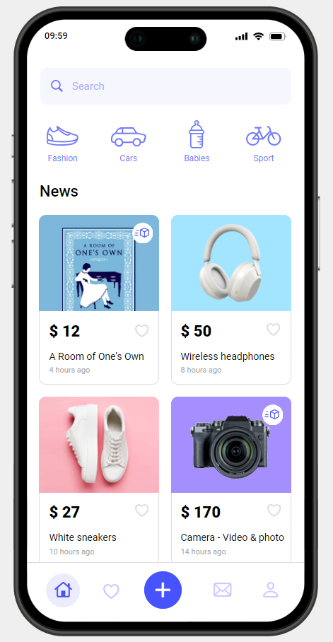
Sample Title Here
Fig 9.0
Vel turpis nunc eget lorem dolor. Nec sagittis aliquam malesuada bibendum arcu vitae. Posuere urna nec tincidunt praesent semper feugiat. Lobortis scelerisque fermentum dui faucibus in ornare quam viverra. Bibendum at varius vel pharetra vel turpis nunc. Tempus egestas sed sed risus pretium quam vulputate dignissim suspendisse. Pretium fusce id velit ut. Mauris ultrices eros in cursus turpis. Velit egestas dui id ornare arcu odio ut. Pretium quam vulputate dignissim suspendisse.

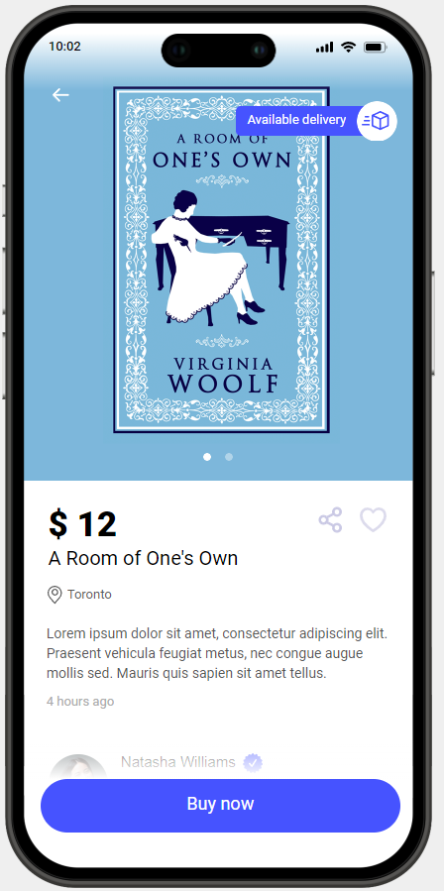
Sample Title Here
Fig 10.0
Vel turpis nunc eget lorem dolor. Nec sagittis aliquam malesuada bibendum arcu vitae. Posuere urna nec tincidunt praesent semper feugiat. Lobortis scelerisque fermentum dui faucibus in ornare quam viverra. Bibendum at varius vel pharetra vel turpis nunc. Tempus egestas sed sed risus pretium quam vulputate dignissim suspendisse. Pretium fusce id velit ut. Mauris ultrices eros in cursus turpis. Velit egestas dui id ornare arcu odio ut. Pretium quam vulputate dignissim suspendisse.

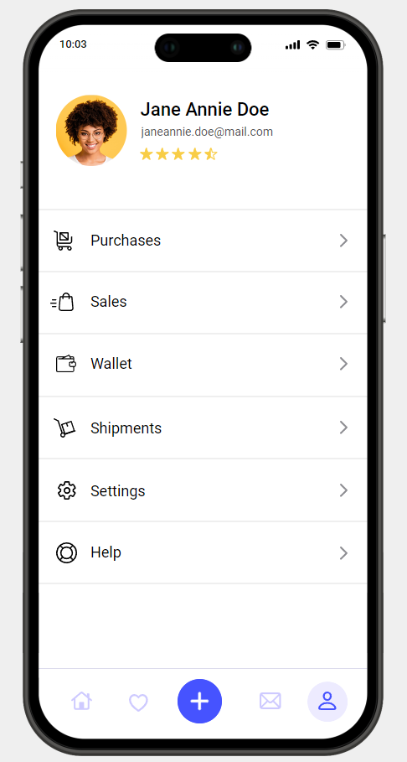
Sample Title Here
Fig 11.0
Vel turpis nunc eget lorem dolor. Nec sagittis aliquam malesuada bibendum arcu vitae. Posuere urna nec tincidunt praesent semper feugiat. Lobortis scelerisque fermentum dui faucibus in ornare quam viverra. Bibendum at varius vel pharetra vel turpis nunc. Tempus egestas sed sed risus pretium quam vulputate dignissim suspendisse. Pretium fusce id velit ut. Mauris ultrices eros in cursus turpis. Velit egestas dui id ornare arcu odio ut. Pretium quam vulputate dignissim suspendisse.

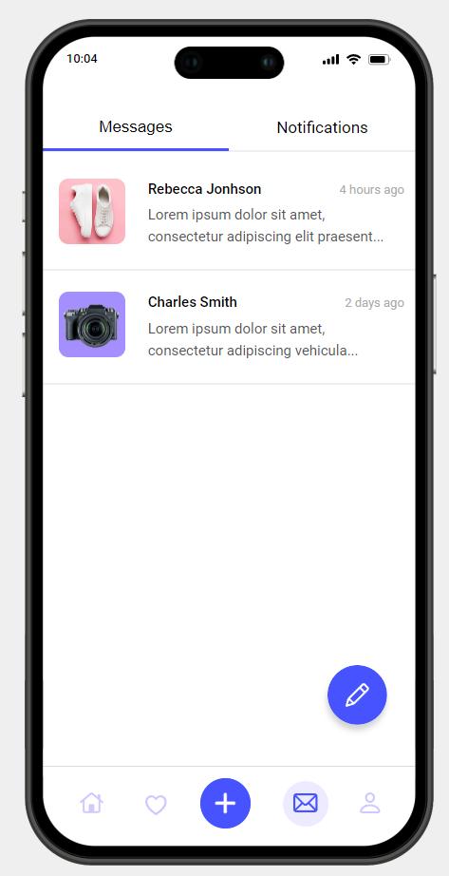
Sample Title Here
Fig 12.0
Vel turpis nunc eget lorem dolor. Nec sagittis aliquam malesuada bibendum arcu vitae. Posuere urna nec tincidunt praesent semper feugiat. Lobortis scelerisque fermentum dui faucibus in ornare quam viverra. Bibendum at varius vel pharetra vel turpis nunc. Tempus egestas sed sed risus pretium quam vulputate dignissim suspendisse. Pretium fusce id velit ut. Mauris ultrices eros in cursus turpis. Velit egestas dui id ornare arcu odio ut. Pretium quam vulputate dignissim suspendisse.

Chapter IV: Software Analysis and Results

To complete this study properly, it is necessary to analyze the data collected in order to test the hypothesis and answer the research questions. As already indicated in the preceding chapter, data is interpreted in a descriptive form.

This chapter comprises a simplified version of the analysis, presentation and interpretation of the findings resulting from this study.

Simplified scoring:

5 = Very satisfied
4 = Satisfied
3 = Neutral
2 = Unsatisfied
1 - Very Unsatisfied

Category | 5 | 4 | 3 | 2 | 1 | Avg.
Usability and User Experience
Feature Evaluation
Technical Support and Documentation
Pricing and Value for Money
Overall

Table 1.0: Averaged surveyed results

< Create a Google Form to create the questionnaire >
< Attach actual survey summary from Google forms here >

Chapter V: Recommendations
< Write a very detailed summary of your application and document including the recommendations provided by the panelists. This chapter should be written in at least 3 paragraphs. >

Sample:

While TaskMaster Pro is a robust and versatile project management tool, there are several areas where it could be improved to further enhance user experience and functionality. By addressing these areas, TaskMaster Pro can better meet the needs of its diverse user base and stay ahead of the competition.

Firstly, TaskMaster Pro would benefit from the addition of more advanced customization options. While the current features are powerful, allowing users to tailor their dashboards, reports, and notifications to their specific preferences and workflows would significantly enhance usability. For example, customizable templates for different project types and industries could streamline the setup process for new projects. Additionally, more flexible notification settings would allow users to control the frequency and types of updates they receive, reducing notification fatigue and ensuring they stay informed about the most critical tasks and deadlines.

Secondly, integrating artificial intelligence (AI) and machine learning (ML) capabilities could take TaskMaster Pro to the next level. AI-driven insights and recommendations could help users optimize their workflows, predict potential project delays, and allocate resources more efficiently. For instance, an AI-powered task prioritization feature could analyze past project data and suggest the most critical tasks to focus on, improving overall productivity. Similarly, ML algorithms could provide predictive analytics, helping managers foresee potential issues and make proactive adjustments to keep projects on track.

Finally, expanding the range of integrations with other software and tools would enhance TaskMaster Pro's versatility. While it already integrates with popular tools like Slack and Google Workspace, adding support for other widely used applications such as Trello, Asana, and various CRM systems would make it even more valuable to users who rely on multiple platforms. Additionally, offering an open API could allow users to create custom integrations tailored to their specific needs, further expanding TaskMaster Pro's capabilities and ensuring it can seamlessly fit into any tech stack.

By focusing on these areas for improvement, TaskMaster Pro can continue to evolve and provide even greater value to its users. Enhanced customization, AI-driven features, and expanded integrations will not only improve user satisfaction but also solidify TaskMaster Pro's position as a leading project management solution in the market.

References

Books and E-Books:
- Thompson, S. (1982). The Year of the Wolf. Preston and Buchanan.
- Thompson, S. (1982). The Year of the Wolf. Preston and Buchanan.
- Thompson, S. (1982). The Year of the Wolf. Preston and Buchanan.

Magazines and Journals:
- Example: Smith, J. (2005, March). Five kinds of chocolate cake. Cakes Around the World, 23 (5), 5-15.
- Example: Smith, J. (2005, March). Five kinds of chocolate cake. Cakes Around the World, 23 (5), 5-15.

Newspapers and RSS:
- Johnson, J. (1997, August 22). Sighting of a black bear has town on edge. The Timberland Herald, 5-6.

Websites:
- Sampson, K. (2011, September 9). The moon and its phases. https://moonphases.com/the-moon-and-its-phases
- Sampson, K. (2011, September 9). The moon and its phases. https://moonphases.com/the-moon-and-its-phases
- Sampson, K. (2011, September 9). The moon and its phases. https://moonphases.com/the-moon-and-its-phases
- Sampson, K. (2011, September 9). The moon and its phases. https://moonphases.com/the-moon-and-its-phases
- Sampson, K. (2011, September 9). The moon and its phases. https://moonphases.com/the-moon-and-its-phases
- Sampson, K. (2011, September 9). The moon and its phases. https://moonphases.com/the-moon-and-its-phases
- Sampson, K. (2011, September 9). The moon and its phases. https://moonphases.com/the-moon-and-its-phases
- Sampson, K. (2011, September 9). The moon and its phases. https://moonphases.com/the-moon-and-its-phases
- Sampson, K. (2011, September 9). The moon and its phases. https://moonphases.com/the-moon-and-its-phases
- Sampson, K. (2011, September 9). The moon and its phases. https://moonphases.com/the-moon-and-its-phases

